Text Summarizer & Categorical

* The following steps for download necessary Library for this project..
* NLTK Library
* Install NLTK using pip pip install nltk .

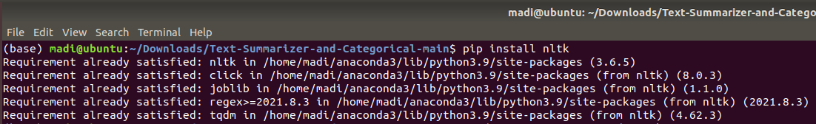

* Install NLTK in anaconda environment conda install -c anaconda nltk .

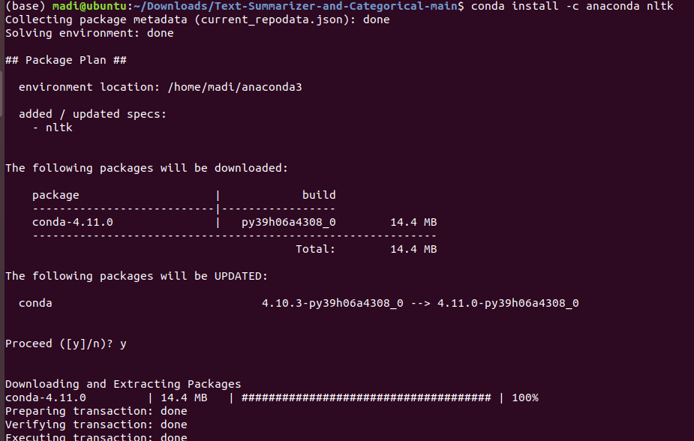

* Pandas Library
* Install Pandas using pip pip install pandas.

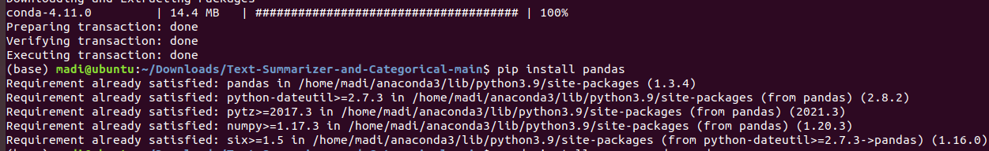

* Install Pandas in anaconda environment conda install -c anaconda pandas.

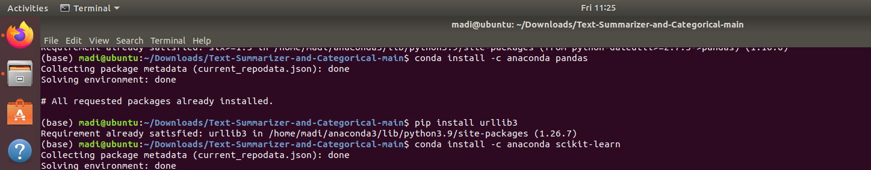

* Urllib & Beautifulsoup4 Libraries
* Install urllib pip install urllib3.



* Install beautifulsoup4 pip install beautifulsoup4.

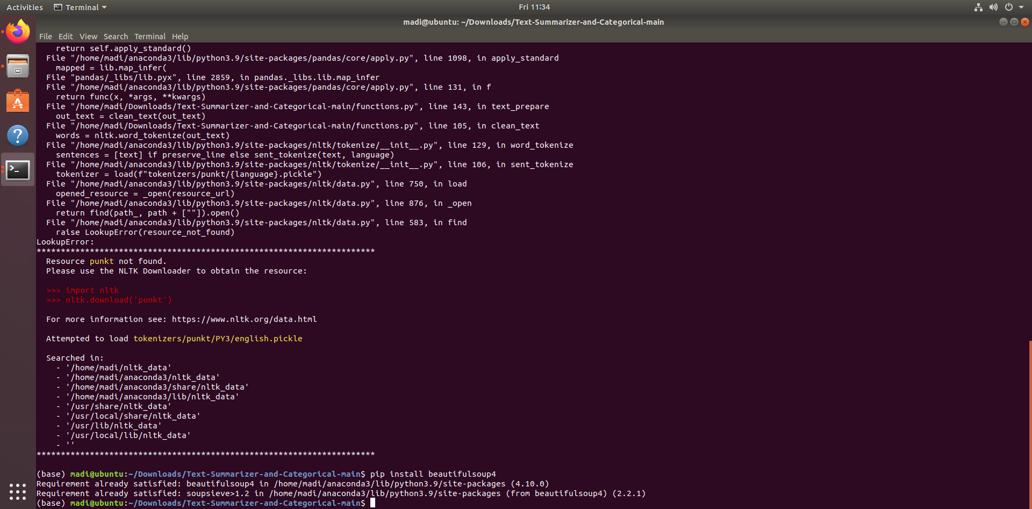

* Scikit Learn
* Install Scikit-learn using pip pip install scikit-learn.

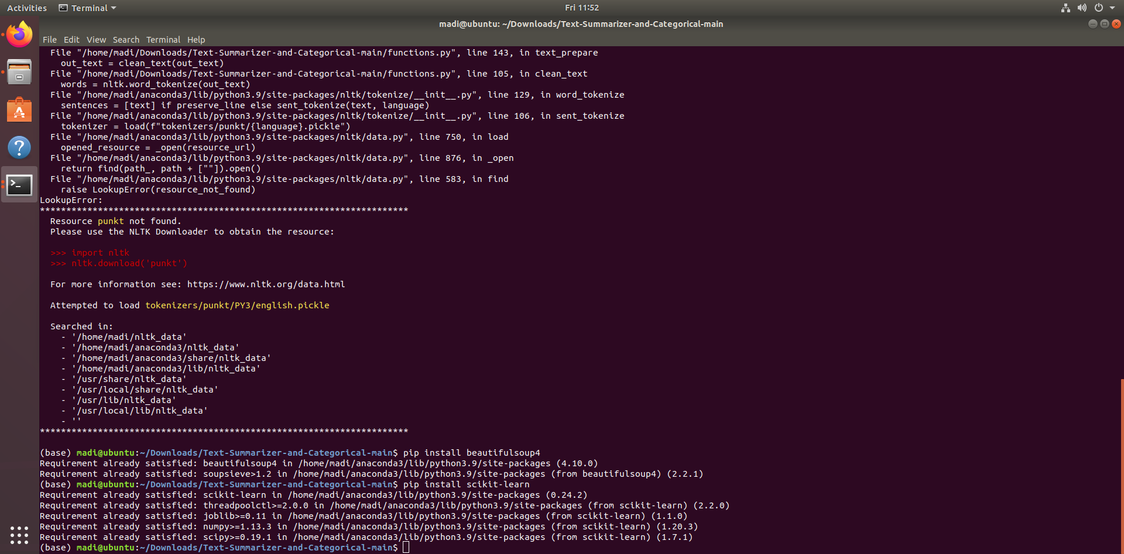

* Install Scikit-learn in anaconda environment conda install -c anaconda scikit-learn.

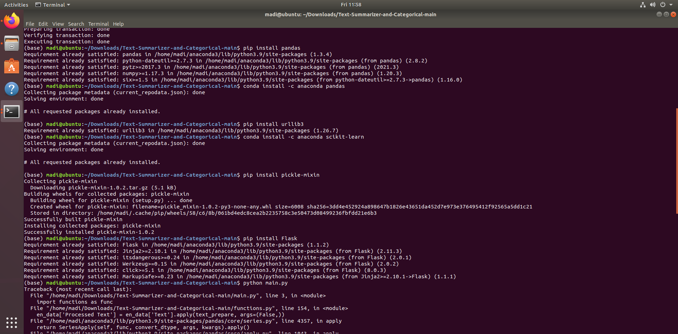

* To save and load models you need to install pickle pip install pickle-mixin.



* Flask Framework
* Install Flask on your machine pip install Flask.



* Usage
* Clone or download this repository <https://github.com/ali-mohamed-nasser/Text-Summarizer-Categorical.git>.
* Before running the code run the following code..

python -m nltk.downloader

* Run the main.py file to start Flask server and use the application.

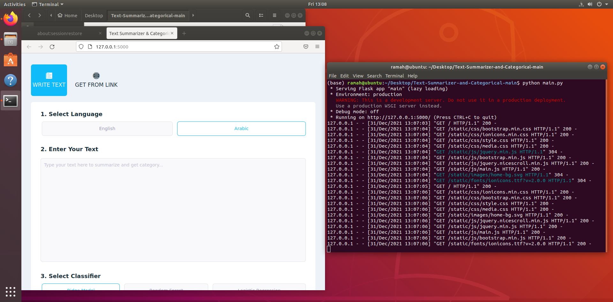

* Output:

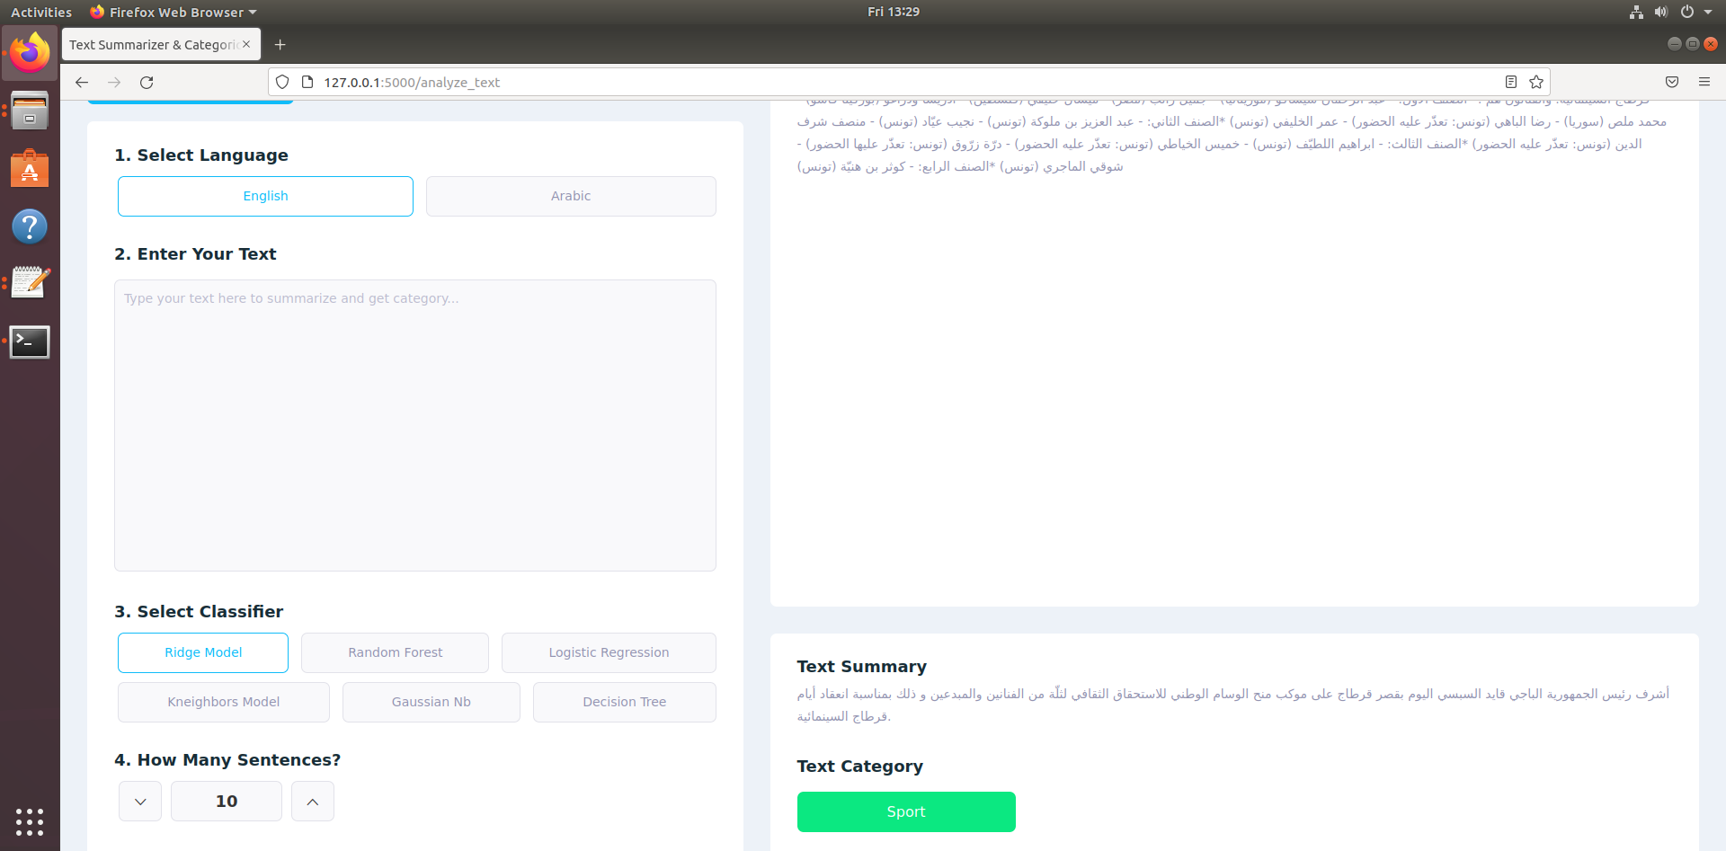

* Name: Ramah Hashem Madi.